**Network Topology**

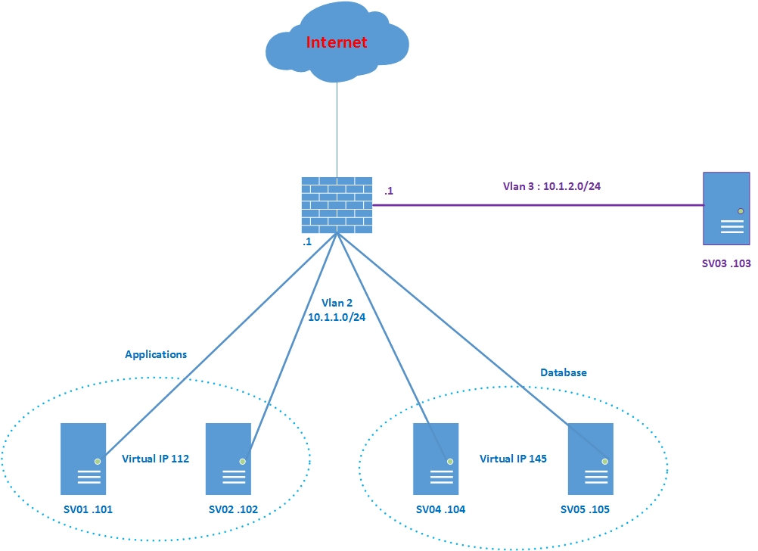

I want to build a systems :

- 2 Server Applications, 2 Server Database in a same vlan 2 (subnet 10.1.1.0/24) .

- Appcations access to database by Virtual IP Database.

- End user in vlan 3 (subnet 10.1.2.0/24) and can access applications by use Virtual IP Applications

I use route mode between Vlan 2 & Vlan 3 and permit any any .

In Server 03, I can ping and access Applications (use http service to test) with Virtual IP 10.1.1.112

In Server 03, I can ping Database with Virtual IP 10.1.1.145

How can I config Appcations Server access to database by use Virtual IP Database ?

I find a topic talk about that use SNAT But I can not config complete .

<https://community.sophos.com/products/unified-threat-management/f/network-protection-firewall-nat-qos-ips/42272/internal-load-balancing>

Please help me config it .

