As per your instruction in the mail; we have added the dyndns & it’s got success also.

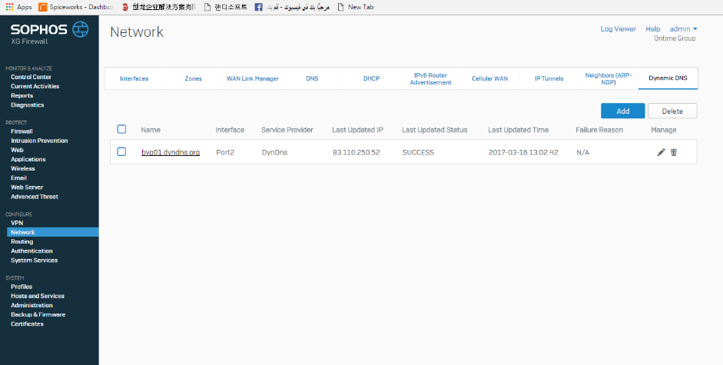

In the site to site VPN configuration; if I select the dyndns the VPN is not getting connecting

## 

Sophos Firmware Details:

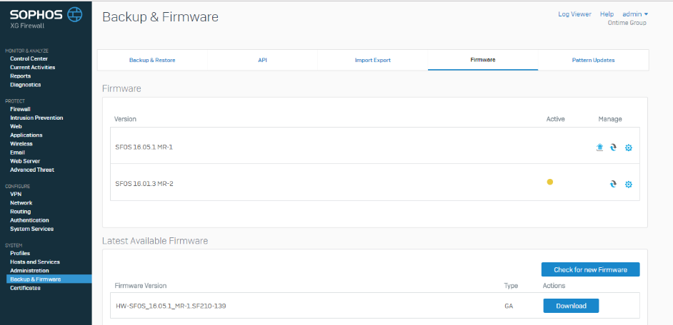

**Interface Details**

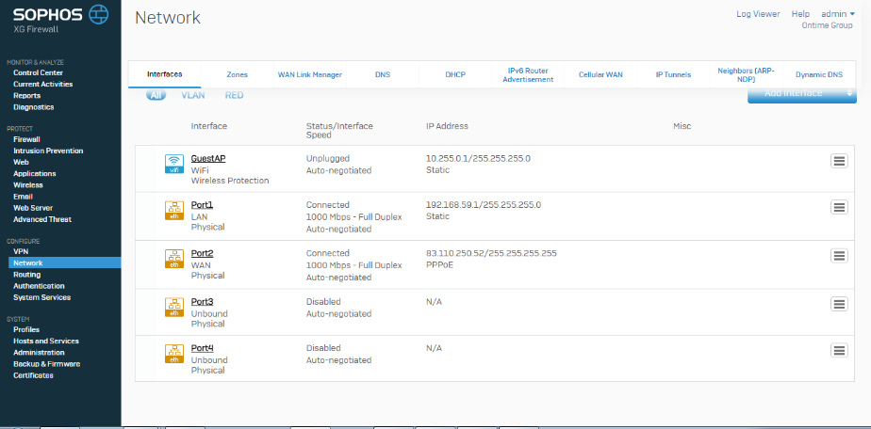

**IPsec Connection VPN: Site to site**; here it’s showing it’s connected because I have done base on IP address but my requirement through dyndns.

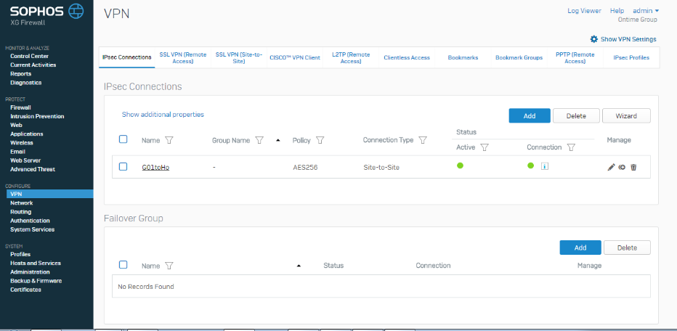

**IPSEC Connection configuration**

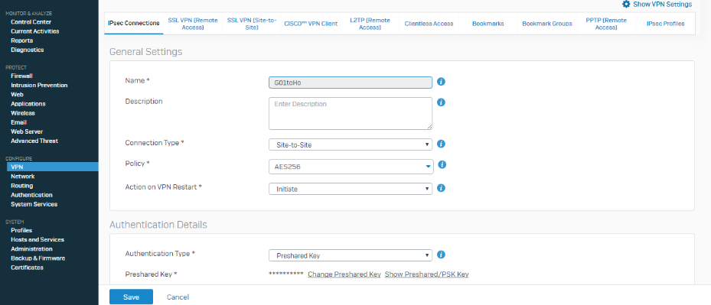

**IPSEC Connection configuration**

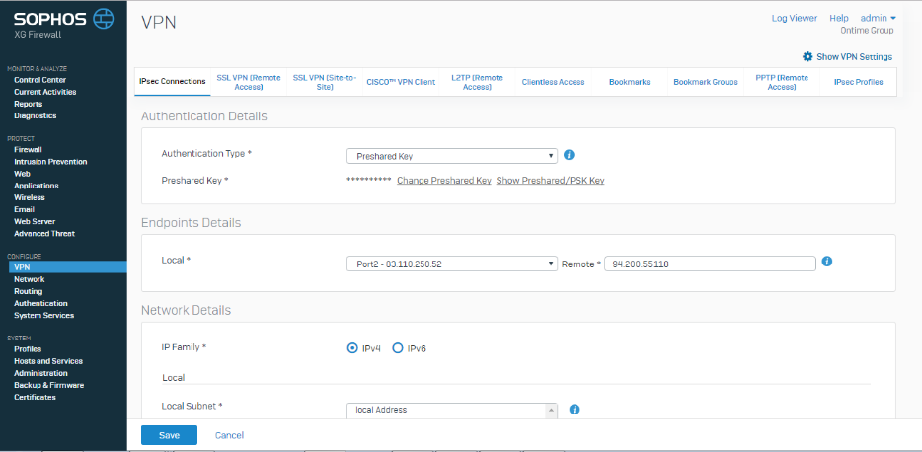

**IPSEC Connection configuration**

This is the place ; In the Local ID column we have availability of giving dyndns; but if I provided that VPN is not connecting.

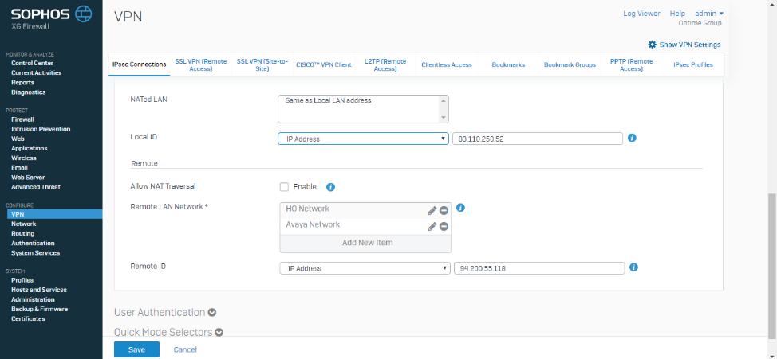

If anyone can help me for this kindly do the needful.